We need you!
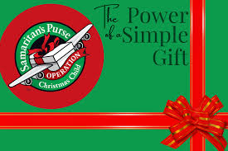
Mark your calendars!!

Operation Christmas Child – Shoebox Packing Party
What: Outreach and Fellowship event for our Church family and friends
When: October 15th (Thursday) beginning at 5:00 p.m. - 7:00 p.m.
Where: Social Hall. Presbyterian Church Shippensburg
On Oct. 15th we are gathering to pack shoeboxes for God’s children all over the world! We will have all the materials to pack the shoeboxes and after a delicious BBQ dinner (also known as Sloppy Joe’s), chips, cookies and brownies, we will fill the shoeboxes.
Please invite your friends and show up to be the hands and feet of Jesus in a world that needs His love! All are invited to join us! Come join us in the fun, fellowship and service in His Kingdom!
If you are unable to attend the packing party, please consider donating with cash (envelope marked Operation Christmas Child) or write a check to the Presbyterian Church Ship (in the memo line of the check Operation Christmas Child) to help with the cost of delivering the shoeboxes all over the world.
